CSA 1533 – CLOUD COMPUTING WITH BIG DATA ANALYTICS WITH BUSINESS INTELLIGENCE
PRACTCAL BOOKLET
1.Create A Cloud Software Application And Provide It As A Service Using Any Cloud Service Provider To Demonstrate Software As A Service (Saas)
AIM :
To design and develop a cloud-based Hotel Reservation Booking System and provide it as a Software as a Service (SaaS) using a cloud service provider, enabling users to book hotel rooms through a web-based application without local software installation
PROCEDURE
- A cloud service provider (such as Zoho Creator) is selected to develop the SaaS application.
- A new cloud application named Hotel Reservation Booking System is created.
- Required forms such as Customer Details, Room Details, and Booking Details are created to manage reservation data.
- The application is hosted on the cloud, allowing users to access it through a web browser.
- Users enter customer and booking information, which is securely stored in the cloud database.
- Reports and dashboards are generated to view booking details and reservation status.
- The application is tested to ensure proper booking functionality and cloud accessibility.

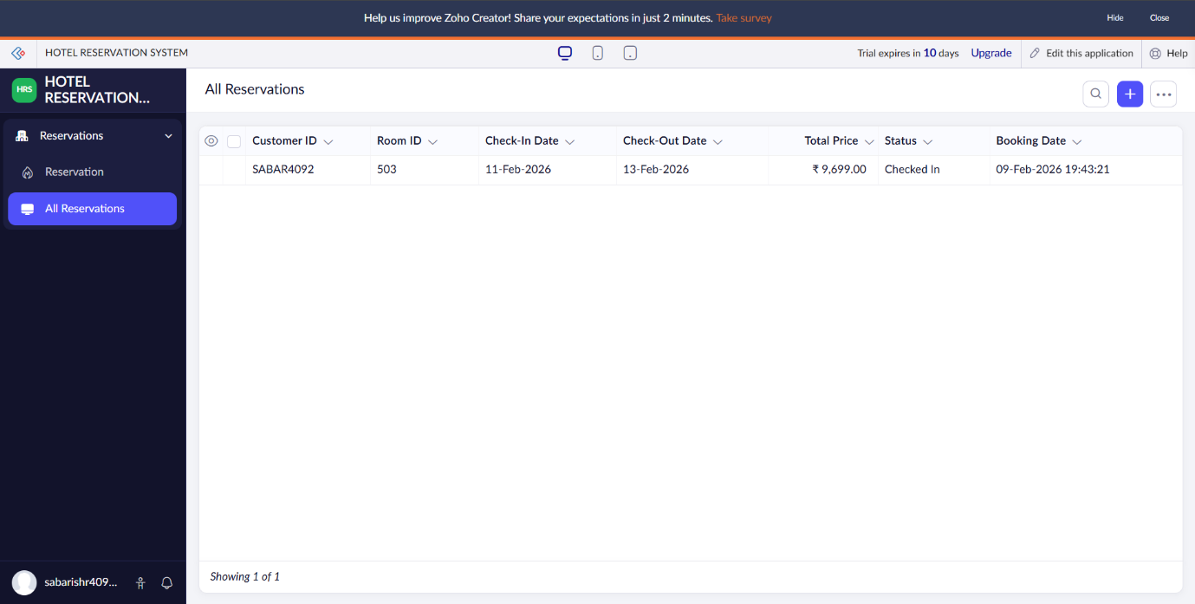
RESULT :

